**Assignment – 4**

2. write a SQL query to Create Stored procedure in the Northwind database to retrieve Employee Sales by Country

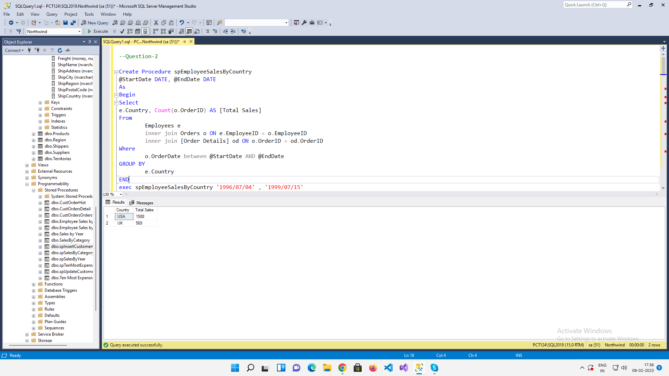

3. write a SQL query to Create Stored procedure in the Northwind database to retrieve Sales by Year

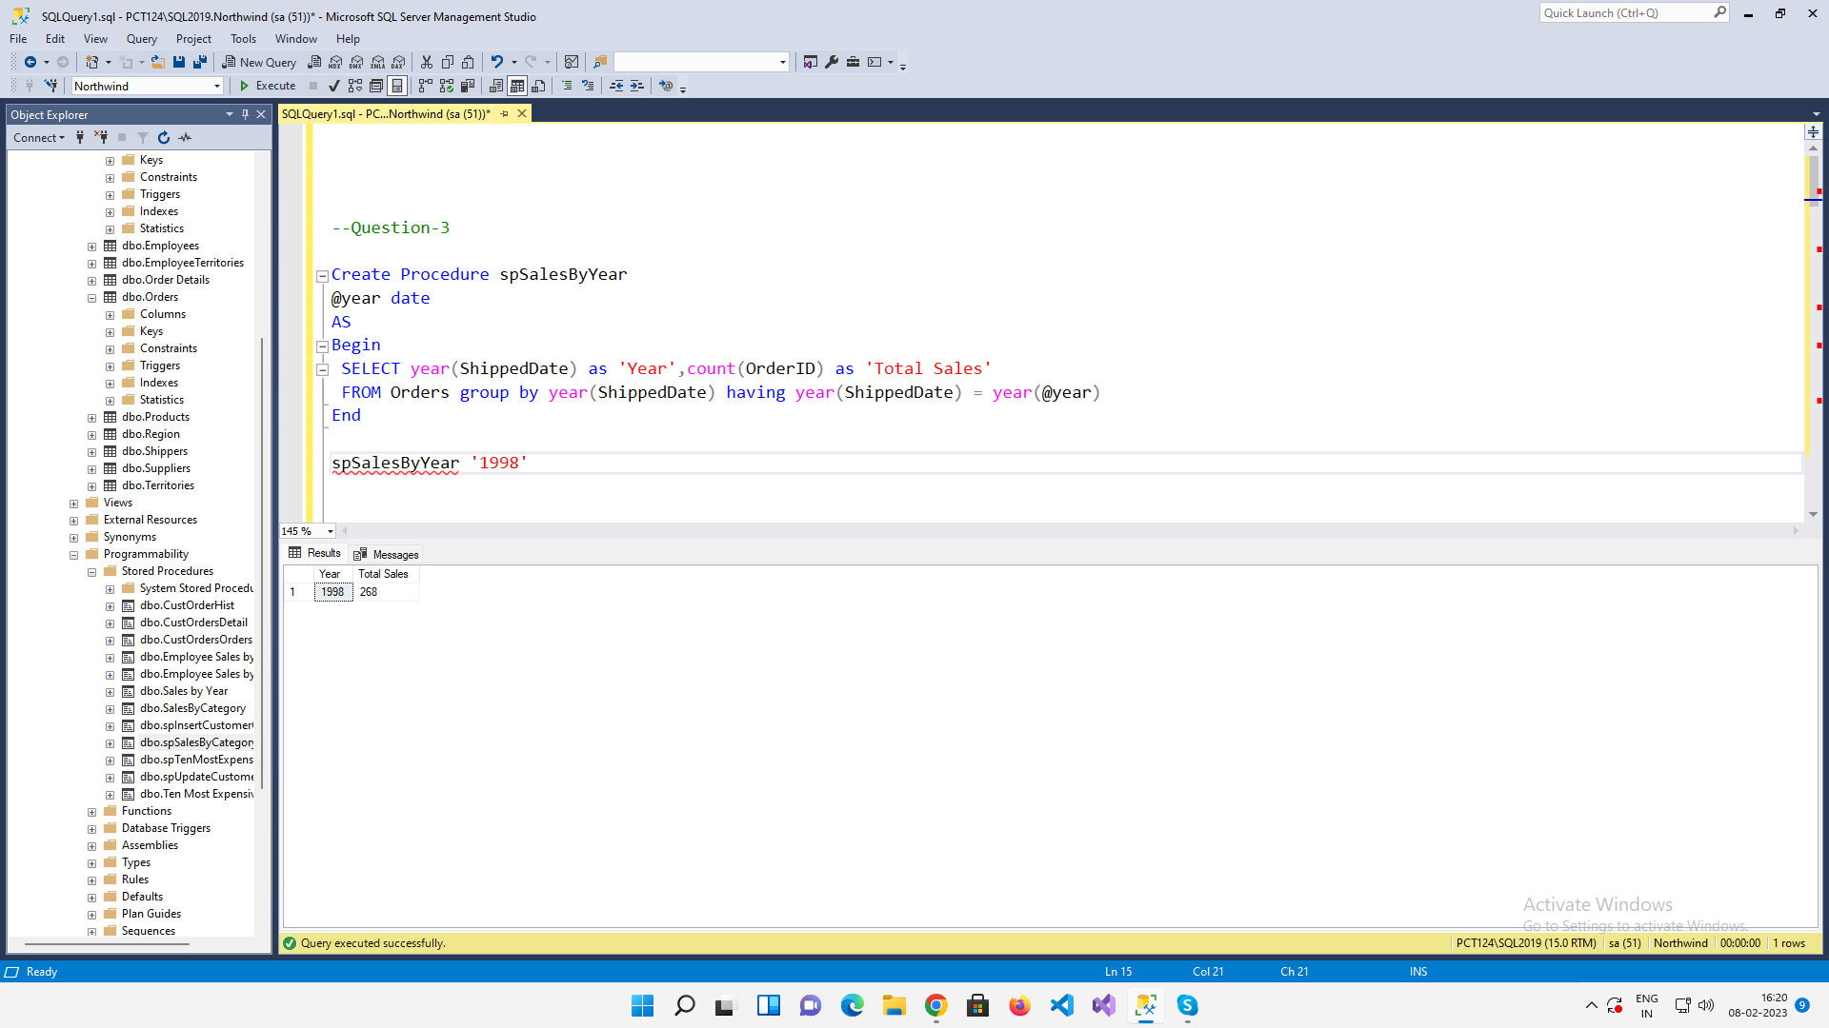

4. write a SQL query to Create Stored procedure in the Northwind database to retrieve Sales By Category

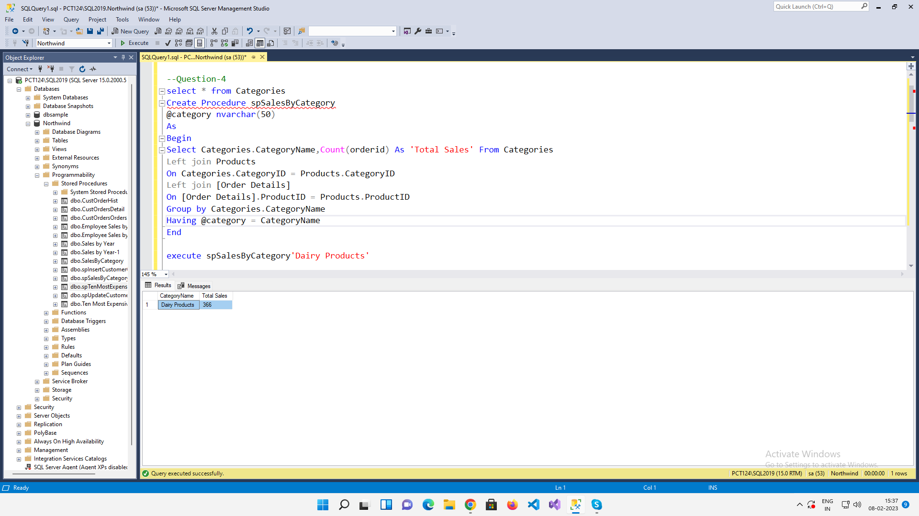

5. write a SQL query to Create Stored procedure in the Northwind database to retrieve Ten Most Expensive Products

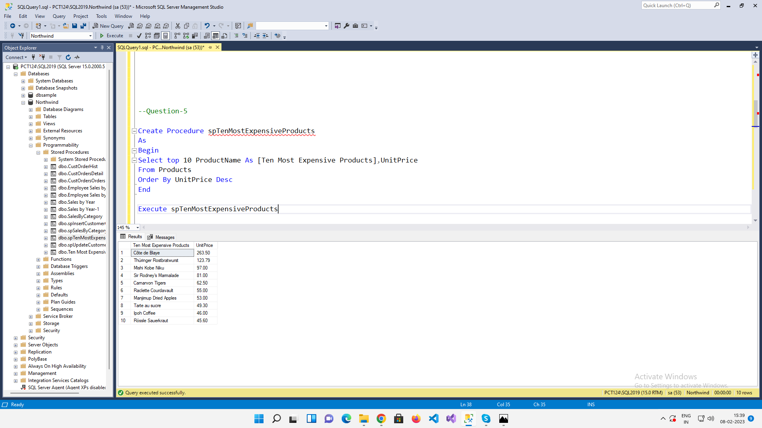

6. write a SQL query to Create Stored procedure in the Northwind database to insert

Customer Order Details

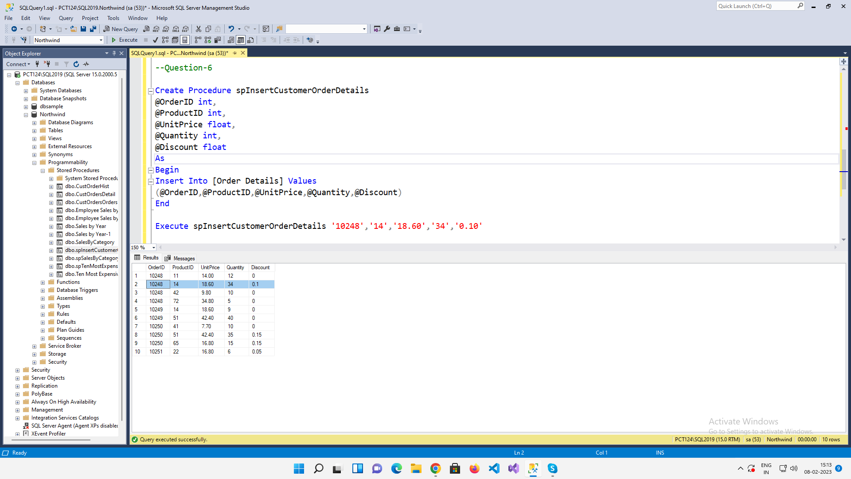

7. write a SQL query to Create Stored procedure in the Northwind database to update

Customer Order Details

